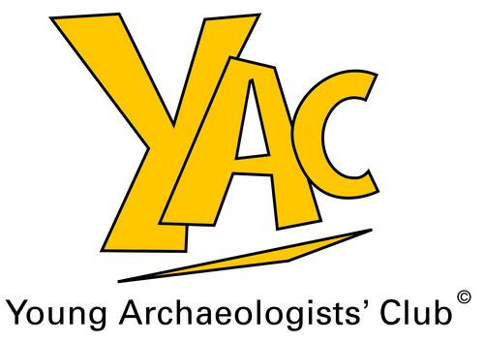

Photographic Permission Form

YAC may take photographic prints and digital images of the young people engaged in the activities. With permission from parents/guardians and young people themselves, these images may be used to promote YAC activities in printed and online publicity material by YAC, the Council for British Archaeology (CBA), Archaeology Scotland (formerly the Council for Scottish Archaeology), CBA Wales/Cymru, the CBA English regional groups, and local YAC Branches. Images are sometimes used in articles in other publications (such as special-interest magazines or newspapers) to illustrate YAC’s activities.

Please be aware that YAC has strict child protection policies on the use of photographic images. Personal information about young people, such as addresses, will never be included. In most cases names will not be used; young people will be referred to simply as YAC members. Full names will only be used in specific circumstances, for example, where a young person is the winner of a YAC competition or has written an article for Young Archaeologist magazine.

For further information, please contact the YAC Network and Events Officer at YAC HQ in York or the Young Archaeologists’ Club Officer at Archaeology Scotland. YAC’s full child protection policy is available on the YAC website (see www.britarch.ac.uk/yac)

If you have any reservations or questions, please discuss them with the YAC volunteer or staff member organising the event/s before signing.
Printed Images:

Examples of uses of printed images:
  - YAC UK’s magazine Young Archaeologist
  - Leaflets and posters for YAC UK
  - Local Branch newsletters
  - Printed material distributed by the CBA (e.g. the Members’ Newsletter and
the flagship magazine British Archaeology)
  - Articles in newspapers and special-interest magazines about YAC’s activities

If you are content that your child may be photographed and appear in such printed material please sign below giving your approval.

✎ Please add child’s name

I give my permission for my child ___________________________________________ to be photographed at YAC events and have no objections to such photographs being used in printed publications and associated publicity as outlined above.

Continued Overleaf

✎ Please complete details (parent/guardian)

Signed: ____________________________ Print Name: _________________________

Relationship to child:______________________________________________________

Home Address:__________________________________________________________

______________________________________________________________________

Tel: __________________________ Email:___________________________________

Date: ___________________________

✎ Please complete details (young person)

Signed: ____________________________ Print Name: _________________________

The Council for British Archaeology is a Company Limited by Guarantee, registered in England 1760254; Registered Charity 287815
Images Online:

YAC and the CBA may use some images of young people engaged in YAC activities to illustrate their websites. Images used for generic/illustrative purposes on the YAC and CBA websites may be replaced with more recent images regularly. Images of young people associated with particular stories or events may remain on the YAC website in perpetuity, but will be archived as new stories and events are added. Local Branches may also wish to use images on their own websites.

If you would like further clarification of YAC’s commitment to safeguarding young people online, please contact YAC HQ in York.

✎ Please tick
I am happy for images to appear on the following websites:

YAC UK website Yes [ ] No [ ]
CBA website Yes [ ] No [ ]
Archaeology Scotland website Yes [ ] No [ ]
Local Branch website Yes [ ] No [ ]

YAC HQ in York: CBA, St Mary’s House, 66 Bootham, York, YO30 7BZ
Archaeology Scotland: Stuart House, Eskmills, Station Road, Musselburgh, EH21 7PB

